ICSE’15 Tutorial Briefing: “The Art and Science of Analyzing Software Data; Part1: Qualitative Methods”

Christian Bird,  Microsoft Redmond, USA,  cabird@gmail.com  http://www.cabird.com | Tim Menzies  CS, NcState Uni, USA  Tim.menzies@gmail.com  http://menzies.us | Thomas Zimmermann  Microsoft Redmond, USA,  tzimmer@microsoft.com  http://thomas-zimmermann.com

Note to reviewers: In ICSE’13 and ICSE’14, we presented tutorials for “data science in SE”. These were well attended (second and first largest tuts for ICSE’13 and ICSE’14 with 21 and 53 attendees, respectively).
This year, we propose separating that tutorial into two briefings: one each on qualitative and quantitative methods.
We believe that ICSE’15 attendees would get much value if both proposals were accepted and run consecutively. That said, each proposal is an independent module (so one can be accepted without the other).

1. Description of briefing:
In the age of big data, data science is an tool for gaining significant insights into software projects. This tutorial reflects on the state-of-the-art in qualitative reasoning in this important field. Our covered material is as follows. (1) Rules of thumb for managers overseeing data analytics teams. (2) Survey methods- specifically, how to run a successful survey, from selecting the population, to survey design, invitations, and analysis of data- statistical analysis, visualization, card sorting, and various other tools. (3)  Interviews: the steps to effective interviewing, including preparation (interview guide), execution (general tips, recording), and analysis (transcriptions, affinity diagramming).
Also, based on feedback from the 2014 tutorial, we proposed extending this 2015 technical briefing as follows. An important qualitative technique in real-world data science are observational studies of practitioners are they perform their day-to-day tasks. Hence, our 2015 briefing will include notes on
(4) How to observe developers during their work and what we can learn from that.

2. More Details:
Note that this section is the same for both our proposals on qualitative and quantitative methods in SE data science.
Target audience: Software practitioners and researchers wanting to understand the state of the art in using data mining for software engineering (SE) data.
Pre-requisites: This tutorial makes minimal use of maths of advanced algorithms and would be understandable by developers and technical managers.
Overall goal of the tutorial: Better data mining by better skilled software engineers.
Why the topic would be of interest to a broad section of the software engineering community: In the age of big data, data science for software engineering is a very active area. In the 21st century, it is now impossible to manually browse all the available software project data. The PROMISE repository of SE data has grown to 100+ projects and this is just one of over a dozen open-source repositories that are readily available to researchers. There are many sources of information; e.g. example, as of Oct’12, Mozilla Firefox had 800K reports on projects; and Sourceforge.net Github host 324K and 11.2M projects.

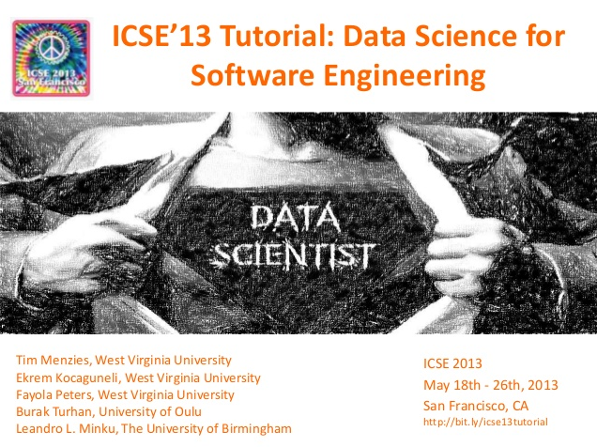 | 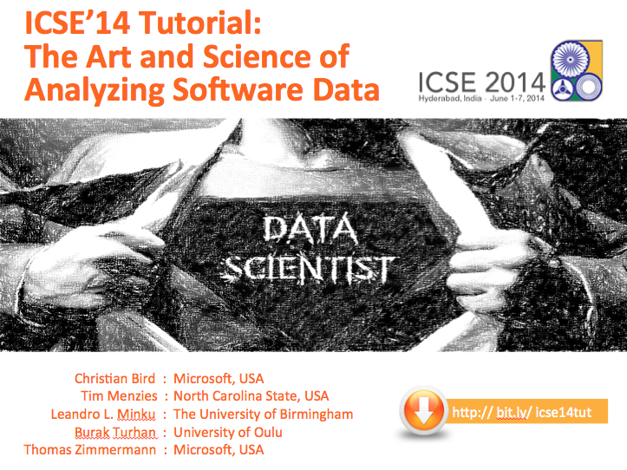
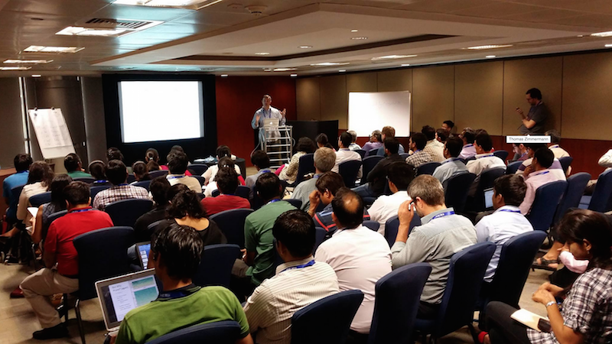
Fig1: This material was presented at ICSE 2013,2014.
The ICSE’14 session was the most tutorial of
that conference (53 attendees).

There are many successful results in this field. For example, after mining data from Microsoft products, Christian Bird found that it was possible to build high-quality software using teams across the planet, just as long as the management is structured around code functionality (who works on what) and not merely on geography (who sits where) [Bird09] Another result from AT&T [Ostrand04] (which has been repeated several times [Menzies10,Tosun10] ) is that it is possible to use static code measures to guide inspection teams to the small parts of the code containing most defects; e.g. inspection teams can find 80% to 88% of the defects after inspecting 20% to 25% of the code. For more examples, see the long list of applications discussed in the July and September 2013 issues of IEEE Software special issues on “Software Analytics”, edited by Menzies & Zimemrmann.
These results have inspired much interest in this kind of data analysis in the industrial and research communities. A search through Amazon.com reveals dozens of new data mining texts, just in the last 2 years. Yet most of those texts are overly concerned with the specific details of particular data miners. Industrial practitioners should be able to use a range of both qualitative and quantitative data mining approaches as decision support tools which allow prediction of useful information on new software projects based on completed projects.

PRESENTERS
The presenters of this tutorial have been active for many years in this area. Their work has found general principles that cover multiple data mining methods. This tutorial will present those principles.
Regarding the presenters tutorial experience:
- All the authors of this proposal wrote and presented the ICSE’14 tutorial on data science.
- Dr. Menzies ran the data science & SE tutorial at ICSE’13. As mentioned above, that tutorial was well attended (it had the second highest attendance of any ICSE’13 tutorial, with 21 registrations).
- Dr. Menzies ran the data mining & SE tutorial at ICSE’12.
- Dr. Menzies presented with Forrest Shull the “Empirical SE v2.0” tutorial, ICSE’11.
Regarding the presenter’s understanding of this field:
- Menzies and Zimmermann recently edited the very successful IEEE Software special issue on software analytics (which received so many submissions that it was split into two issues: July and September 2013).
- Bird, Menzies and Zimmermann are editing a forthcoming book with Morgan Kaufmann on Analyzing Software Data, due for release late 2014.
- Menzies and Zimmermann are co-organizers of a Dagstuhl 2014 seminar on software development analytics.
- Drs Menzies and other is also writing a book “Data Mining for Software Engineering”, Morgan Kaufmann Press, due for release late 2014.

Tim Menzies is a full Professor in Computer Science at NcState University. He has 200+ refereed publications. His experience in data analysis is extensive. He is the author of over 200 refereed publications and one of the co-founders for the PROMISE repository for repeatable SE experiments. Since, 2001 he has been one of the leading proponents of applying data mining to software engineering data. His paper on data mining SE data in TSE’07 is the highest cited paper in that journal for 2007 to 2012 [Men07]. He is the inventor of two new data mining algorithms (TAR3 and KEYS2) and is one of the co-organizers of the PROMISE conference on data mining SE data. He has organized workshops for ICSE 1999; ICSE 2005; ICSE 2007, ICSE 2012 and co-located conferences for ICSE 2008; ICSE 2009. He was the PC co-chair for ASE 12 and is member of the editorial boards of IEEE TSE, ESE, JLVC, ASE journal. He organized all the PROMISE conference meetings from 2005 to 2011. He has organized special issues for journals for the Empirical SE journal (five times), the Requirements Engineering journal, IEEE Intelligent Systems, and twice for the Journal of Human-Computer Studies. He was co-chair of the IEEE ASE’12 program committee and will be co-chair of the ICSE’15 NIER track. As a result of all the above, Dr. Menzies has an extensive collection of contacts in the international scientific community.
Christian Bird is a researcher in the empirical software engineering group at Microsoft Research. He is primarily interested in the relationship between software design, social dynamics, and processes in large development projects and in developing tools and techniques to help software teams. He has studied software development at Microsoft, IBM, and in the Open Source realm, examining the effects of distributed development, ownership policies, and the ways in which teams complete software tasks. He has published in the top Software Engineering venues including three ACM SIGSOFT Distinguished papers and Communications of the ACM. Christian received B.S. in computer science from BYU and his Ph.D. from U.C. Davis under Prem Devanbu. Chris has organized and run many workshops, including the Workshop on Release Engineering (2013), the largest attended workshop at ICSE 2013, the workshop on Data Analysis Patterns in Software Engineering (ICSE 2013), and the workshop on Replications in Software Engineering Research (2010-2013). He has served on the PCs of both ICSE and FSE, was the MSR mining challenge PC Chair (2008), the Industrial track PC co-chair of ICPC 2013, and is the PC co-chair of ICPC 2015.
Thomas Zimmermann received his Ph.D. degree from Saarland University in Germany. He is a researcher in the Research in SE group at Microsoft Research Redmond, adjunct assistant professor at the University of Calgary, and affiliate faculty at University of Washington. His research interests include mining software repositories, empirical software engineering, analytics, and digital games. He is best known for his research on systematic mining of version archives and bug databases. He co-organized a working session on Myths in Software Engineering, the DEFECTS workshops (2008 and 2009) as well as the RSSE workshops on recommender systems (2008, 2010, and 2012). He served as PC co-chair (2010 and 2011) and General Chair (2013) for the conference on mining software repositories (MSR)

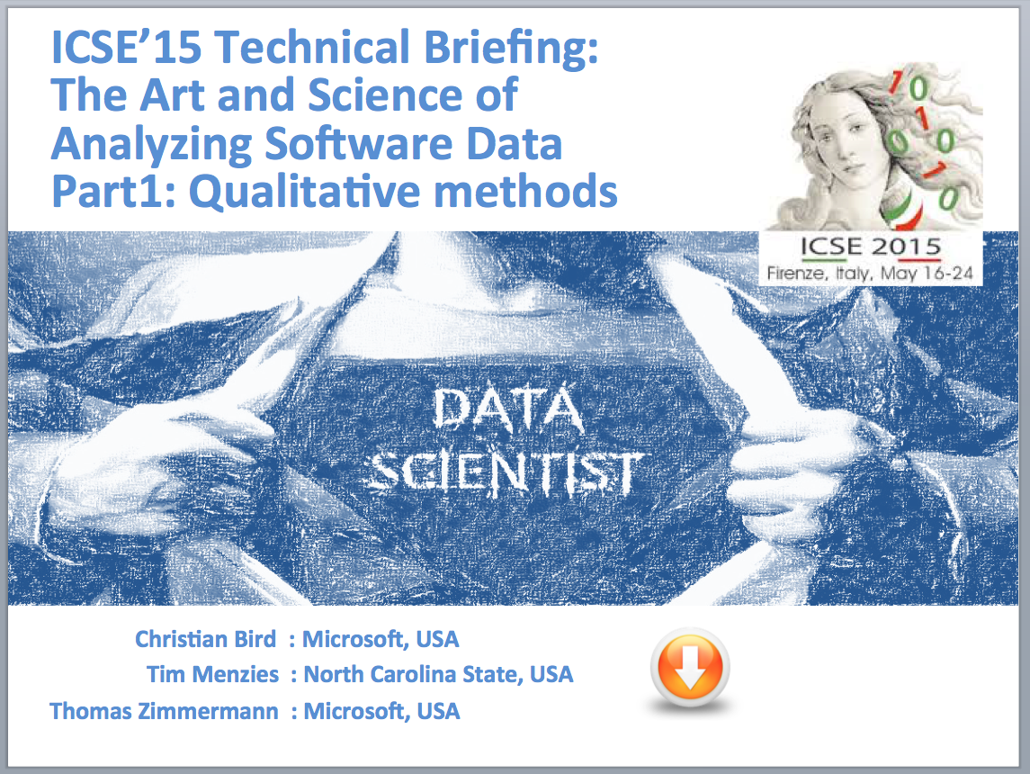
SAMPLE SLIDES
We have already begun dividing the 2014 three hour tutorial into two 90 minute briefings for ICSE 2015.

Looking over the existing material, and the additional notes we want to add, we can several interesting ways to unify material from different sections while presenting new material.

Based on that analysis, we can see how to generate two solid sets of 65 slides.

For the current draft of the tech briefing on qualitative methods, please see :

http://unbox.org/open/trunk/15/icse/techbrief/ICSE15TechBriefingDataScienceQual-v1.pptx

