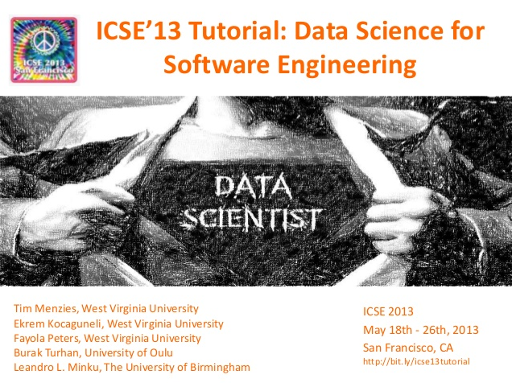 | 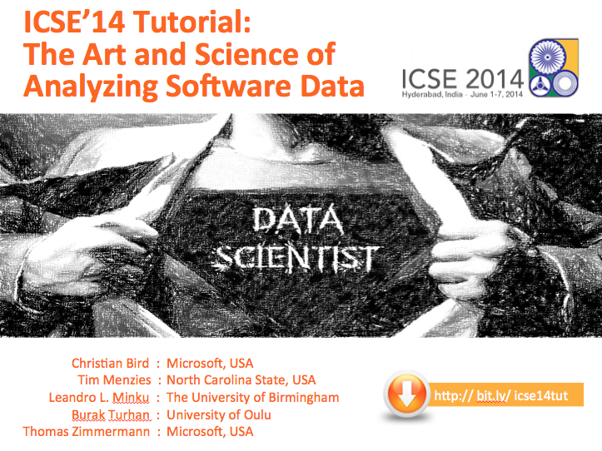
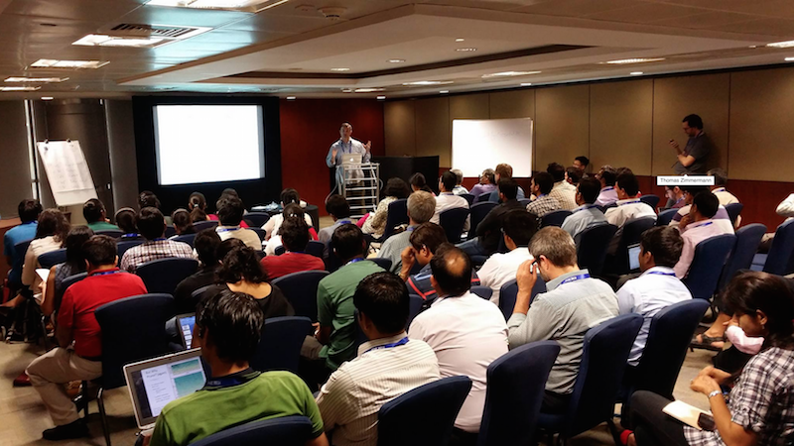
Fig1: This material was presented at ICSE 2013,2014.
The ICSE’14 session was the most tutorial of
that conference (53 attendees).
ICSE’15 Tutorial Briefing: “The Art and Science of Analyzing Software Data; Part2: Quantitative Methods”

Tim Menzies  CS, NcState, USA  Tim.menzies@gmail.com,  http://menzies.us | Leandro L. Minku  CS, U. Birmingham, UK  l.l.minku@cs.bham.ac.uk  http://www.cs.bham.ac.uk/~minkull | Fayola Peters  LERO, University of Limmerick, Ireland  fayolapeters@gmail.com  http://fayolapeters.com/

Note to reviewers: In ICSE’13 and ICSE’14, we presented tutorials for “data science in SE”. These were well attended (second and first largest tutorials for ICSE’13 and ICSE’14 with 21 and 53 attendees, respectively).
This year, we propose separating that tutorial into two briefings: one each on qualitative and quantitative methods.
We believe that ICSE’15 attendees would get much value if both proposals were accepted and run consecutively. That said, each proposal is an independent module (so one can be accepted without the other).
1. Description of briefing:
Using the tools of quantitative data science, software engineers can predict useful information on new projects based on past projects. This tutorial reflects on the state-of-the-art in quantitative reasoning in this important field. This tutorial discusses the following: (a) when local data is scarce, we show how to adapt data from other organizations to local problems; (b) when working with data of dubious quality, we show how to prune spurious information; (c) when data or models seem too complex, we show how to simplify data mining results; (d) when the world changes, and old models need to be updated, we show how to handle those updates; (e) When the effect is too complex for one model, we show to reason over ensembles.
Based on feedback from the ICSE’14 tutorial, we will also extend that material as follows. We will add to the 2015 briefing notes on (f) certain landmark results in the history of the field plus (g) more recent landmark and very influential papers such as the association rule methods for guiding programmers to related changes (the methods won a “Most Influential Paper” award at ICSE’14 for Zimmerman et al “Mining Version Histories to Guide Software Changes”).
2. More Details:
Note that this section is the same for both our proposals on qualitative and quantitative methods in SE data science.
Target audience: Software practitioners and researchers wanting to understand the state of the art in using data mining for software engineering (SE) data.
Pre-requisites: This tutorial makes minimal use of maths of advanced algorithms and would be understandable by developers and technical managers.
Overall goal of the tutorial: Better data mining by better skilled software engineers.
Why the topic would be of interest to a broad section of the software engineering community: In the age of big data, data science for software engineering is a very active area. In the 21st century, it is now impossible to manually browse all the available software project data. The PROMISE repository of SE data has grown to 100+ projects and this is just one of over a dozen open-source repositories that are readily available to researchers. There are many sources of information; e.g. example, as of Oct’12, Mozilla Firefox had 800K reports on projects; and Sourceforge.net Github host 324K and 11.2M projects.

There are many successful results in this field. For example, after mining data from Microsoft products, Christian Bird found that it was possible to build high-quality software using teams across the planet, just as long as the management is structured around code functionality (who works on what) and not merely on geography (who sits where) [Bird09] Another result from AT&T [Ostrand04] (which has been repeated several times [Menzies10,Tosun10] ) is that it is possible to use static code measures to guide inspection teams to the small parts of the code containing most defects; e.g. inspection teams can find 80% to 88% of the defects after inspecting 20% to 25% of the code. For more examples, see the long list of applications discussed in the July and September 2013 issues of IEEE Software special issues on “Software Analytics”, edited by Menzies & Zimemrmann.
These results have inspired much interest in this kind of data analysis in the industrial and research communities. A search through Amazon.com reveals dozens of new data mining texts, just in the last 2 years. Yet most of those texts are overly concerned with the specific details of particular data miners. Industrial practitioners should be able to use a range of both qualitative and quantitative data mining approaches as decision support tools which allow prediction of useful information on new software projects based on completed projects.

PRESENTERS
The presenters of this tutorial have been active for many years in this area. Their work has found general principles that cover multiple data mining methods. This tutorial will present those principles.
Regarding the presenters tutorial experience:
- All the authors of this proposal wrote and presented the ICSE’14 tutorial on data science.
- Dr. Menzies and Minku and Peters ran the data science & SE tutorial at ICSE’13. As mentioned above, that tutorial was well attended (it had the second highest attendance of any ICSE’13 tutorial, with 21 registrations).
- Dr. Menzies ran the data mining & SE tutorial at ICSE’12.
- Dr. Menzies presented with Forrest Shull the “Empirical SE v2.0” tutorial, ICSE’11.

Regarding the presenter’s understanding of this field:
- Menzies recently co-edited the very successful IEEE Software special issue on software analytics (which received so many submissions that it was split into two issues: July and September 2013).
- Menzies was co-organizers of the Dagstuhl 2014 seminar on software development analytics.
- Drs Menzies and Minku and other is also writing a book “Data Mining for Software Engineering”, Morgan Kaufmann Press, due for release late 2014.
Tim Menzies is a full Professor in Computer Science at NcState University. He has 200+ refereed publications. His experience in data analysis is extensive. He is the author of over 200 refereed publications and one of the co-founders for the PROMISE repository for repeatable SE experiments. Since, 2001 he has been one of the leading proponents of applying data mining to software engineering data. His paper on data mining SE data in TSE’07 is the highest cited paper in that journal for 2007 to 2012 [Men07]. He is the inventor of two new data mining algorithms (TAR3 and KEYS2) and is one of the co-organizers of the PROMISE conference on data mining SE data. He has organized workshops for ICSE 1999; ICSE 2005; ICSE 2007, ICSE 2012 and co-located conferences for ICSE 2008; ICSE 2009. He was the PC co-chair for ASE 12 and is member of the editorial boards of IEEE TSE, ESE, JLVC, ASE journal. He organized all the PROMISE conference meetings from 2005 to 2011. He has organized special issues for journals for the Empirical SE journal (five times), the Requirements Engineering journal, IEEE Intelligent Systems, and twice for the Journal of Human-Computer Studies. As a result of all the above, Dr. Menzies has an extensive collection of contacts in the international scientific community. For example:
- He was co-chair of the IEEE ASE’12 program committee.
- In 2015 he will be co-chair of the ICSE’15 NIER track.
- In 2016, Dr. Menzies he will be co-general Chair for the IEEE ICMSE’16 conference.
Leandro L. Minku is a Research Fellow at the Centre of Excellence for Research in Computational Intelligence and Applications (CERCIA), School of Computer Science, the University of Birmingham (UK). He received the PhD degree in Computer Science from the University of Birmingham (UK) in 2011, and was an intern at Google Zurich for six months in 2009/2010. He was the recipient of the Overseas Research Students Award (ORSAS) from the British government and several scholarships from the Brazilian Council for Scientific and Technological Development (CNPq). His research focuses on software prediction models, online/incremental machine learning for changing environments, and ensembles of learning machines. He has published in internationally renowned journals such as ACM Transactions on Software Engineering and Methodology, IEEE Transactions on Knowledge and Data Engineering, and Neural Networks.

Fayola Peters is a Postdoctoral Researcher with Lero - The Irish Software Engineering Research Center at the University of Limerick in Ireland. She received the PhD in Computer Science from West Virginia University in 2014. Her research focuses on handling privacy issues related to supporting privacy preserving data sharing for data owners as well as software users. She has published at top software engineering venues like ICSE, IEEE TSE and ESEM. She has also been a curator for the PROMISE repository since 2011.

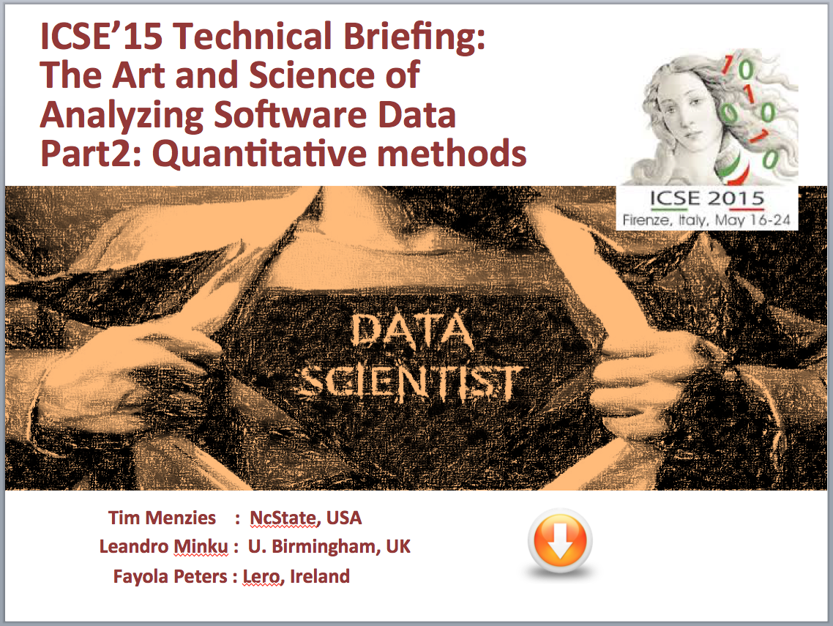

SAMPLE SLIDES

We have already begun dividing the 2014 three hour tutorial into two 90 minute briefings for ICSE 2015.

Looking over the existing material, and the additional notes we want to add, we can several interesting ways to unify material from different sections while presenting new material.

Based on that analysis, we can see how to generate two solid sets of 65 slides.

For the current draft of the tech briefing on quantitative methods, please see :

http://unbox.org/open/trunk/15/icse/techbrief/ICSE15TechBriefingDataScienceQuant-v1.pptx

